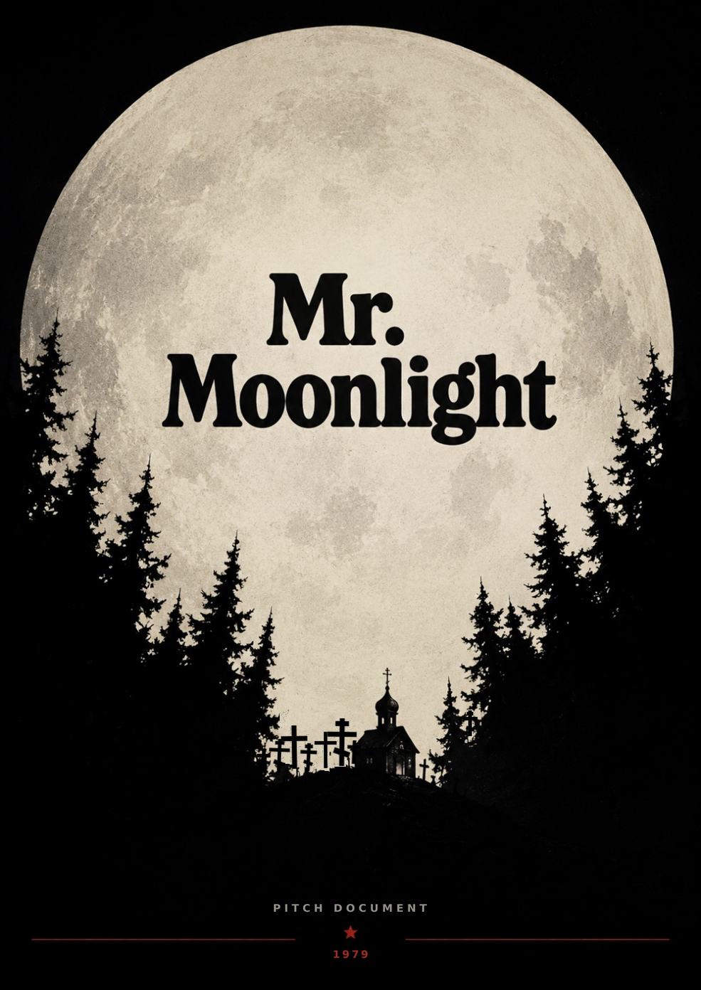INDEX

Click any entry to jump to that section. Click the section title to come back here.
01 ELEVATOR PITCH
02 WHAT'S THIS ABOUT?
03 DRAMATIS PERSONAE
04 PLAYER CONTROLS
05 WORLD BUILDING
06 THE GESTALT OF IT ALL
07 GAME MECHANICS AND MAIN FEATURES
08 THE ENEMY
09 GENERAL ITEMS

SECTION 01
ELEVATOR PITCH
↑ back to index
GAME GENRE | FPS with exploration and horror elements. Gritty, heavy combat against deadly enemies that makes you consider your options. Ludonarrative focus for exposition and tutorial elements.
GOAL SYSTEM (MVP LAUNCH) | PC — itch.io release first, Steam page and demo to follow shortly after.
GOAL SYSTEMS | PC (itch.io, Steam, GOG). Xbox, PlayStation, Switch. (A mobile version is kept in mind during design.)
INTENDED PLAYER DEMOGRAPHIC | Young adults to adults (18+), niche focus.
INTENDED ESRB RATING | Mature (17+) Adults Only (18+). Display of blood and gore, portrayal of substance abuse, religious, ethical and blasphemous topics, mental health topics, foul language, depictions of nudity.

LORE
A group of friends, a weeklong camping trip, a remote Alaskan island. Trying to have one last good time together before important adulthood changes… Something goes wrong.
You are Tracey, a grumpy drug addict who tries to save their kidnapped friends from a cult that will sacrifice them at the end of the week.
There is something about the island: each night its terrain goes through a deadly shape-shift and forces you to look for shelter before 3 a.m.
GAME MECHANICS
THE ISLAND | Each day, the map of the island and its locations change procedurally. Navigation and exploration are aided by maps and a compass.
TASKS | Each day there are objectives (turn on a power generator, find a friend, fix a boat, and so on). A day-and-night cycle is supported by a dynamic lighting system. You need to complete the objectives and find shelter before 3 a.m.
DRUGS SYSTEM | A substance system provides instant buffs and drawbacks, and can develop long-term symptoms that affect your player controller and visuals.
ENEMIES | Each day introduces increasingly bizarre and dangerous enemies and environmental threats.

PRODUCTION
ART STYLE | Low-poly style (PS1/N64), pixelated textures, well-defined silhouettes for enemy design. Cold, high-contrast color palette. Heavy focus on audio design. Punk/grunge/acid elements.
GAME ENGINE | Unity 6.3 LTS.
DEV TOOLS | Blender, Photoshop, Substance Painter/Designer, FL Studio, Audacity.

RELATED GAMES
SLENDERMAN: THE EIGHT PAGES, 2012 | An entity hunts you while you look for items randomly placed in a dark forest.
MISERY, 2025 | Survival game set in a surreal, S.T.A.L.K.E.R.-inspired wasteland where you must return to your base for shelter before a nuke goes off each day.
DUSK, 2018 | Boomer shooter, Doom/Quake-inspired FPS where you fight a cult and supernatural creatures, with a crude, violent low-poly style.
THE FOREST, 2018 | Survival game where you manage resources in a forest while a cult of cannibals attacks you constantly.

INTENDED LAUNCH DATES
MVP | Launch on itch.io, first week of September. The Steam page launches with a demo in the following weeks.
FULL GAME | TBD, ideally mid-2027. (Aiming for Steam Next Fest or another festival with an updated demo before the full launch date.)
SECTION 02
WHAT'S THIS ABOUT?
↑ back to index
STORY
1979. AANNIARVIK ISLAND, ALASKA.
Seven friends approach a time in their lives when they must make important decisions. Fearing an end to their friendship, they take a break from the hardened Alaskan life and travel to an island for a final party: a weeklong camping trip with booze and more stuff to make it memorable.
Aanniarvik was inhabited by natives a long time ago. During WWII it was an American base, ready for a Japanese invasion that never happened. Now it is an empty island with a population of a single forest ranger.
You are Tracey, a twenty-something with some nasty antics and habits: a history-major college dropout in possession of a grumpy potty mouth. You didn't want to come along, but your friends insisted way too much. Okay, one more time.

Camping as a kid was fun, but now everything feels heavy and stupid. Maybe I should go easy this time...................................................
Great, I feel great! Give me a minute... bleehh, false puke alarm everybody... hey! Hello? Not funny guys, where are my boots?... where... where is everyone?

GAME FLOW (LOOP)
Mr. Moonlight is a first-person shooter that never breaks perspective.
Exploration is a key component of the game: every day the layout of the map changes procedurally, which gives the game replay value.
The combat is gritty and slow. Every bullet counts and every blow drains your stamina, so you need to be careful. There are things you should not face head-on. Managing your items properly is vital.
The game consists of seven days. Each day you must complete a specific objective and get back to a shelter before 3 a.m. Each day becomes harder and weirder.
Losing conditions: getting killed, failing to complete the objectives, or failing to escape each day. Losing takes you back to the beginning of the day (there is a limited-use manual save system).
The following is a diagram of the basic game loop. Detailed features and systems will be covered in the Architecture and System Document (not in the scope of this GDD).
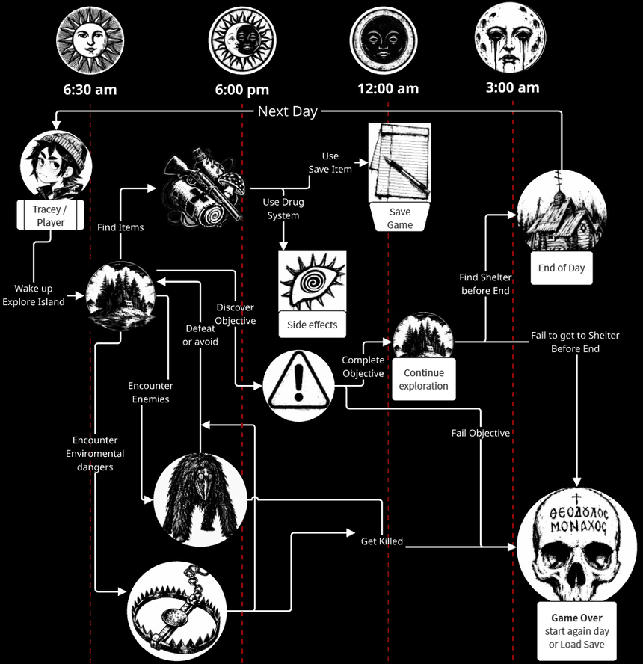
Fig. 1 — Basic game loop
SECTION 03
DRAMATIS PERSONAE
↑ back to index
(as seen by Tracey)
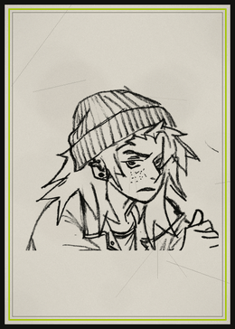  TRACEY  What can I confess about me? Addict, asshole, dull. | 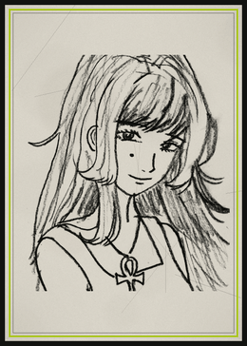  HOLLY  Miss Perfect. She is a nice person, but HOLY FUCK, you can't be that nice all the time. Spoiled brat. | 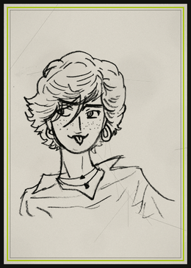  RYLEE  Who would know? Lady jester wants to be a nurse; standup comedy would suit her better. | 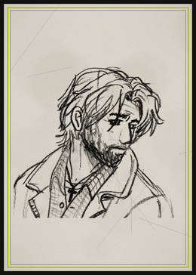  SCOTT  Come on Scott! Why did you dodge the draft and still want to join the air force!!? Fine, get lost in space.
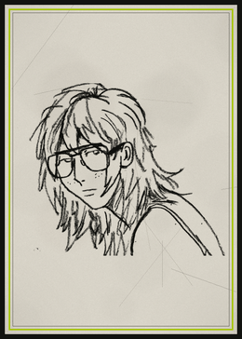  SHANNON  *clears throat, dork voice* “sha-sha-sha-shannooon!!” I said it right? Just kidding! I still don't like that drawing you made of me. | 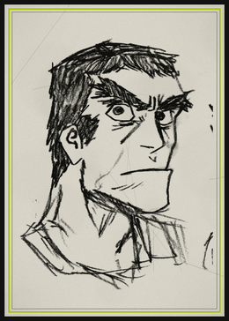  ROBERT  Talk about bigger and dumber. Not that he is a bad person, he just hates the Man too. | 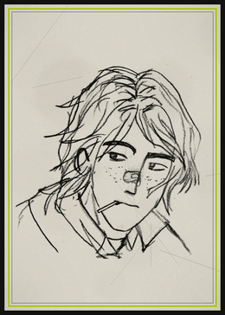  WILLIAM  We are still friends with him? Well, I might bring my stereo so he can fix it. | 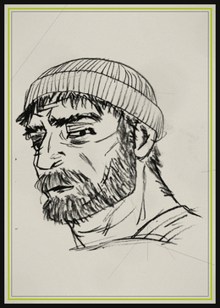  VERNON  Holly's uncle, I think he's a convicted felon or a hermit or something, I don't know.
SECTION 04
PLAYER CONTROLS
↑ back to index
KEYBOARD DISTRIBUTION
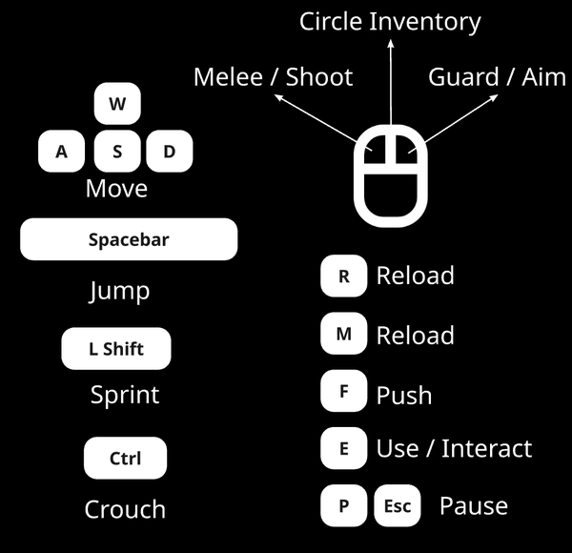
CONTROLLER DISTRIBUTION
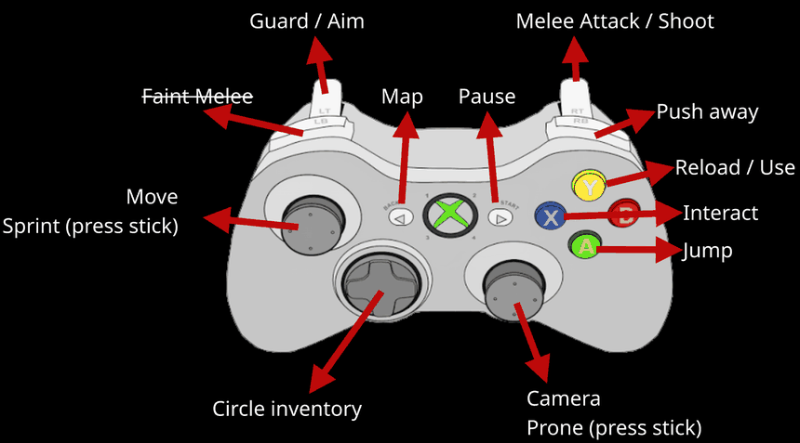
SECTION 05
WORLD BUILDING
↑ back to index
Aanniarvik is small, but big enough: a forest in the middle of the sea. There is an old dock that allows ferry transportation. You might find some locations hidden here and there; they speak of other times and other goals. For now, Aanniarvik is your prison. Don't get used to it, as things tend to move around. Always be on the lookout for dangers and trinkets.
The geography of the island and the distribution of its locations change every day, using a procedural algorithm.
LOCATIONS
The following are some of the locations that spawn across the map. They currently use placeholder conceptual images.
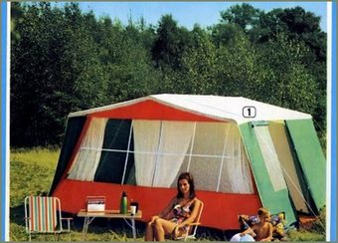  CAMPING SITE  All the stuff brought over on the ferry (yes, including the RV), a couple of tents, the marital-sized tent with the waterbed, the fireplace and a general mess. | 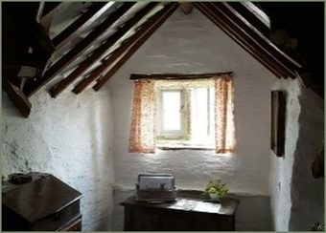  VERNON'S CABIN  Small hermit cabin. It's more of a box than a cabin. Still, warm inside. | 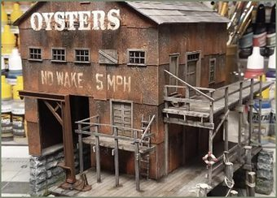  DOCK  The only entry point to the island. The place is in ruins.
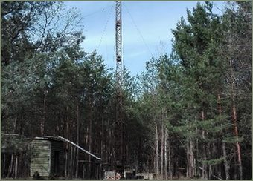  RADIO STATION / WORKSHOP  Some G.I. hoped to use this to call in reinforcements a few decades ago. Still a useful place. | 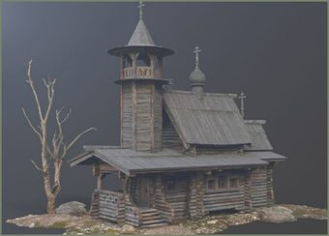  CHAPEL  Vestige of a distant missionary era. No services. Well maintained. | 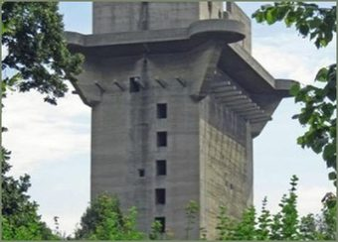  FLAK TOWER  Built with the strength and power to fend off a bomber formation.
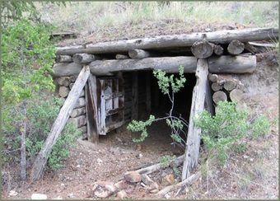  MINESHAFT  Was there ever anything of value here? | 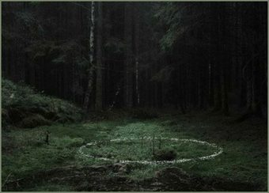  OBSERVATION POST  Places where we can mount the telescope and watch the night sky. | 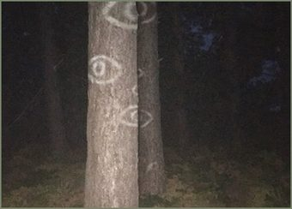  THE FOREST  All around us, ever changing.
SECTION 06
THE GESTALT OF IT ALL
↑ back to index
This section describes the look and feel of the game as a list, with heavy use of pictures.
KEYWORDS
The following are a few keywords, in no strict semantic order, that can speak about the setting, the gameplay or the art style.
SUBSTANCE ABUSE | PUNK-ACID STYLE | FOUL LANGUAGE | CRUDE COMBAT
CLAUSTROPHOBIC DARKNESS | ITEM MANAGEMENT | HALLUCINATIONS | ADDICTION
EXPLORATION | PROCEDURAL TERRAIN | TIME LIMIT | REGRET
MONSTERS | TRAPS | DAY AND NIGHT CYCLE | HIDE AND SEEK
OBJECTIVE CENTRIC | NIGHT SKY

ART STYLE
The game will be a 3D low-poly game with an art style inspired by the 5th generation of consoles. Simple models, but with well-defined silhouettes.
Textures will be pixelated. The overall color palette sticks to cold green, grey and brown tones. The intention is to use Pixel8r with Substance Painter for this process.
UI elements and menus will be minimalist, with minimum text: simplistic, but high-contrast and in a punk/acid/grunge style.
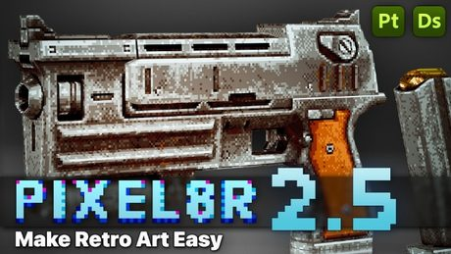
INSPIRATION COLLAGE
The following images give some of the look and feel of the game, akin to concept art but more on an inspiration level.
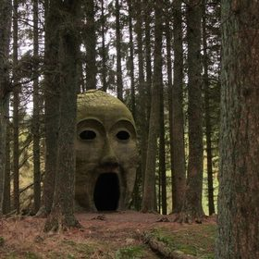 | 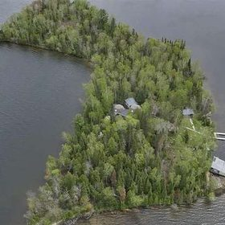 | 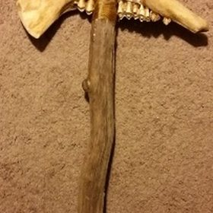 | 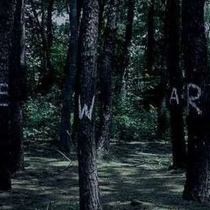
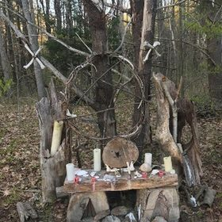 | 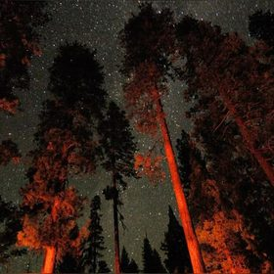 | 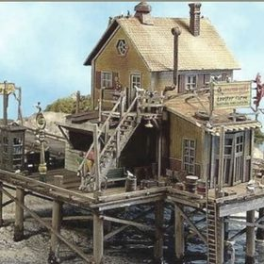 | 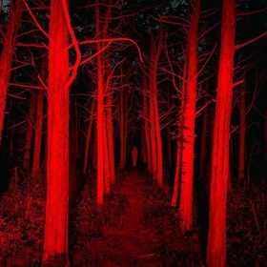
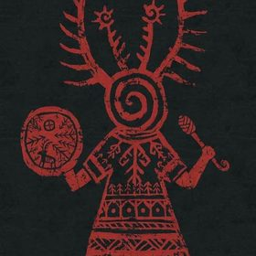 | 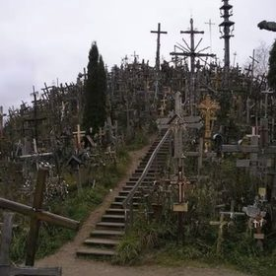 | 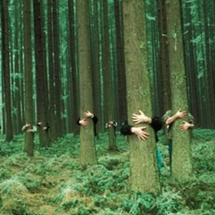 | 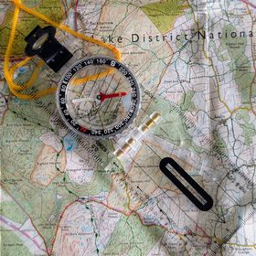
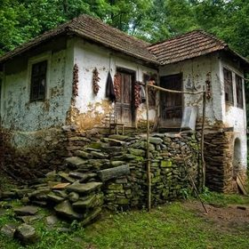

SOUND DESIGN
For the best game experience, a good headset is recommended, as the sound design will be tuned with stereophonic tricks and effects such as the Doppler effect, and sound is also used to detect threats and find places.
The game has little music; it is more about environmental atmosphere. Some props (like trees) might have their own sound sources. There are a couple of scores for the main menu and the ending, plus drum and percussion tracks that will be used during hallucination states or special cinematics.
THEMES AND TOPICS
This is a mature game that will explore topics often shunned in mainstream products. The narrative unfolds gradually, with punctual, sparse dialogue during the game that hints at much deeper character development.
SUBSTANCE ABUSE  At the beginning of the game the player will be unaware that Tracey is a drug addict. This is in fact a trait that shines through your use of the drug system. Drugs in the game have a practical function, with positive buffs and hard drawbacks: a rock-paper-scissors system that requires you to balance it or abuse it. Narratively, this topic is important for the game. | RELIGION  There will be depictions of Christianity, based on the first Russian settlers of Alaska and on the faiths of some characters. Some of the props and enemies have pagan and demonic traits. Initially, the exposition and meaning of this are mainly left to interpretation and mystical symbolism for the player. There is, however, a purpose and a meaning for it.
ETHICAL TOPICS  It's 1978, and you are young. Make love, not war. Or something like that. This is a time when the morals of a nation were under evaluation after the Vietnam War. Society shifts and chooses its new boogeymen. A secular world brings freedom and choices, but at what cost? Each character has a distinct character arc that puts a specific moral question on the table. | MENTAL HEALTH  Tracey is a rude, almost hostile junkie who prefers to be alone. She wasn't always like this. The character development in this game deals with topics inside our heads that we often don't say out loud. At later stages of the game, especially the last day (outside of this MVP), these topics will have a stronger presence.

MOCKUP SCREENS
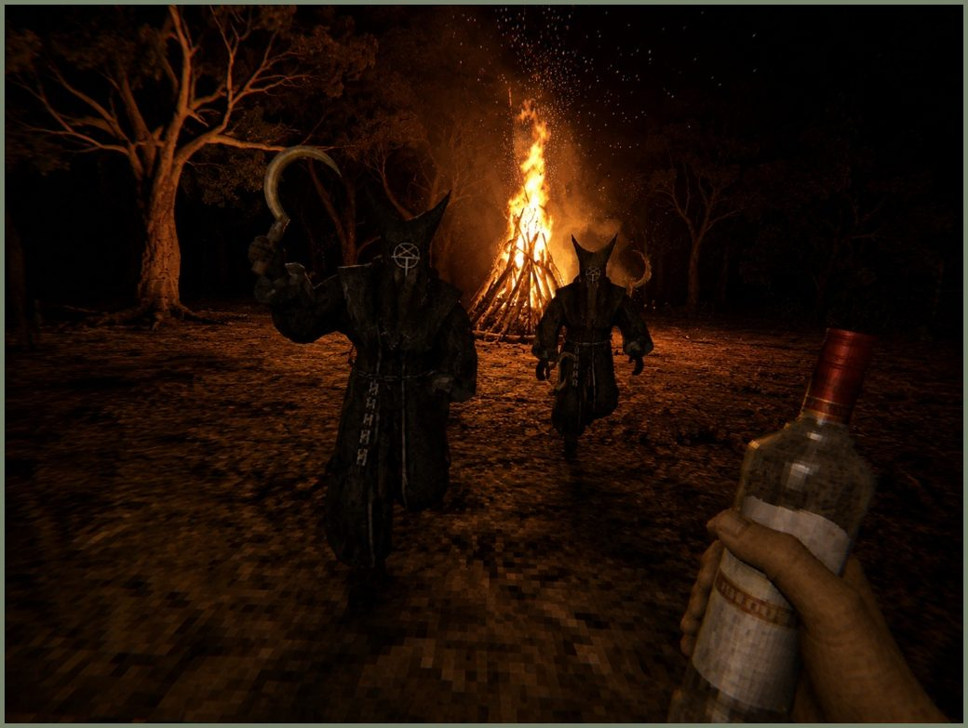  A pair of zealot cultists chases the player, who is about to use the vodka to gain a melee and defensive buff. | 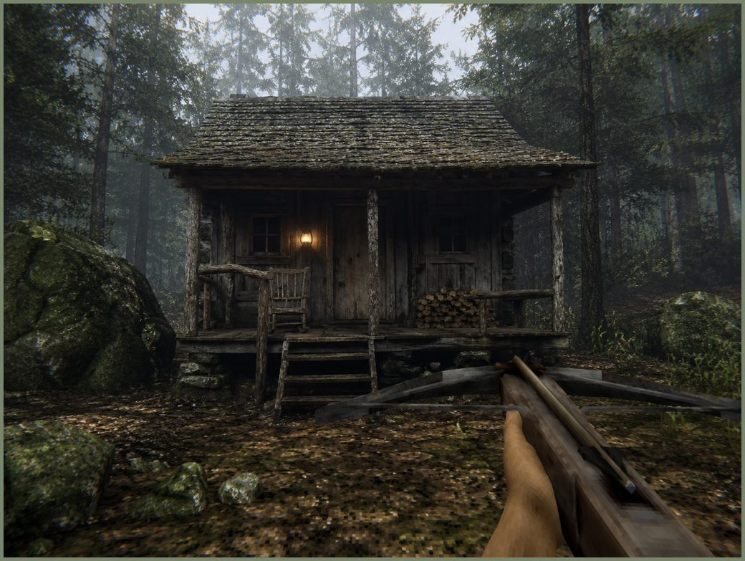  The player approaches a cabin in the woods with a crossbow at the ready.
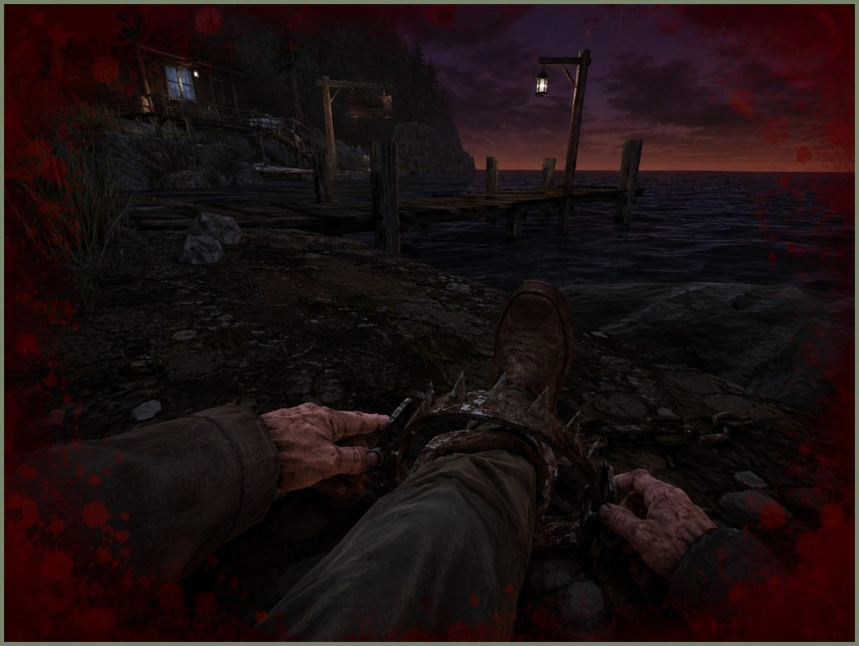  The player tries to free himself from a bear trap. | 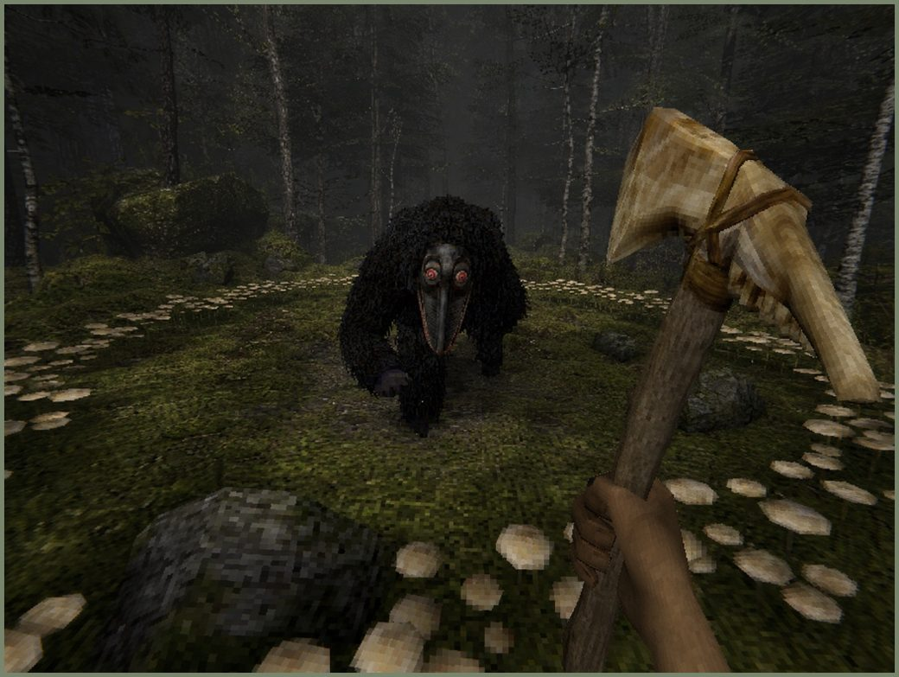  A Furman charges the player, who only has a bone axe for defense.
SECTION 07
GAME MECHANICS AND MAIN FEATURES
↑ back to index
THE ISLAND
As a base, a series of techniques is used to generate terrain with Perlin noise. This package can handle different parameters to alter the specifications of the terrain, and different biomes.
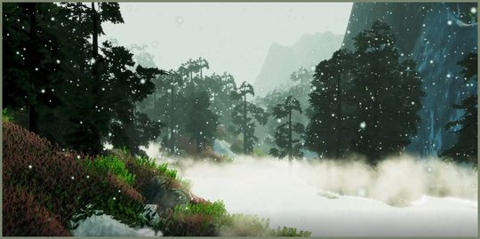 | 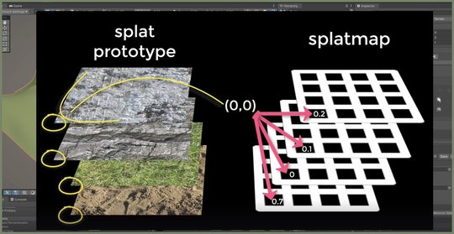
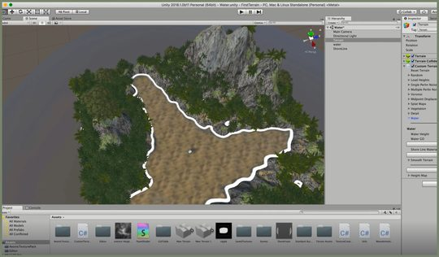 | 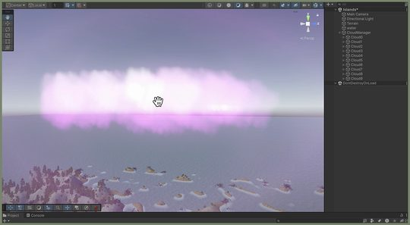

DRUG SYSTEM
Some items are substances that, when used, bring negative and positive effects in the short term and under long use. The following are short descriptions of their use and implications.
ALCOHOL  Gives a temporary buff to melee damage, as well as reducing fear levels. Long use will impact player movement, aim and stamina, and increase the risk of sudden blackouts or vomiting.  INSTANT USE  + melee damage + damage reduction − blurry effect − reduced stamina  PROLONGED USE  + heavy damage reduction + berserker mode − prone to vomiting − slow movement − can induce blackouts | MARIJUANA  Helps with reducing fear and anxiety. It also helps reduce hand shaking when aiming. Using it constantly affects your sound perception and makes you prone to hallucinations.  INSTANT USE  + reduces fear + reduces shaking + healing boost − hearing pitch affected − can suddenly make you laugh (enemies can spot you)  PROLONGED USE  + heals + stamina boost − can induce auditory hallucinations − slows movement − can produce time skips − increases fear after it wears off
SHROOMS  Found in the wild. They induce hallucinations and heighten light perception. They can be useful in situations with limited visibility. In the long run, they impact your hallucinations and enemy behavior.  INSTANT USE  + improves night vision − induces hallucinations − gives enemies an increased fear factor  PROLONGED USE  + allows you to see certain enemies + allows you to see trails − gives enemies additional buffs and extra attacks − heavy hallucinations − blackouts | MORPHINE  Improves health regeneration and grants a buff for damage reduction. Using it constantly will impact your stamina drainage and the damage you take.  INSTANT USE  + fast healing + damage reduction + reduces shaking − nausea − increases fear factor  PROLONGED USE  + immunity to certain attacks + large instant heal − random heart attacks − blackouts − can develop withdrawal symptoms
FPS MECHANICS
The basics of a player controller, enemy behavior, combat system, inventory system, jumpscare and event system manager, interaction system, and flashlight mechanic.
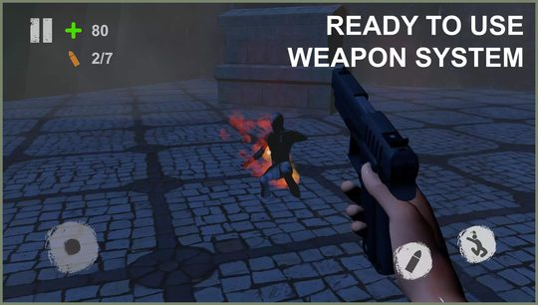 | 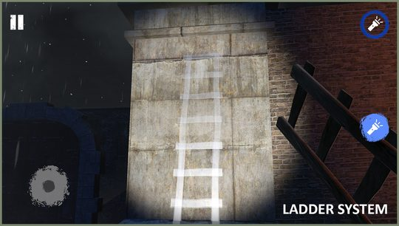
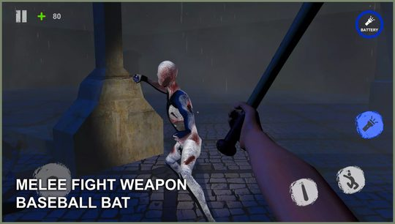 | 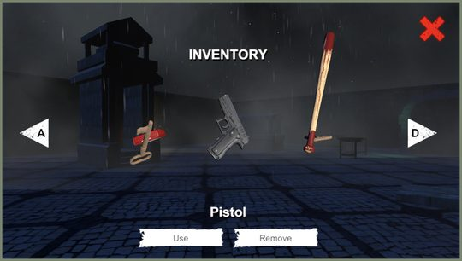

SOUND SYSTEM
Important to the atmosphere of the game. There must be a well-thought-out audio manager system that can trigger sounds depending on levels of fear and hallucination. This is a well-tuned system that provides information about nearby enemies and locations.
DIALOG SYSTEM
In order to have a “show, don't tell” ludonarrative style, a simple dialog system triggers a sound line on certain events that adds bits of game info and narrative without over-exposition.
Really, I just want to enable subtitles whenever a character is talking, in plain white text, akin to the early Silent Hill games.
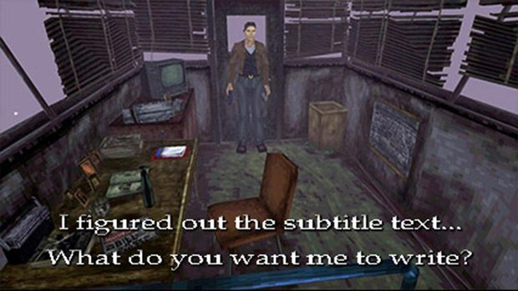
ANIMATIONS
To aid the ludonarrative style mentioned above, a lot of the language will be corporal, with special care taken over arm and hand animation when handling weapons or moving around.
Bearing in mind the limitations and available tools, for this MVP I shall make heavy use of a video-to-mocap tool that will speed up any type of humanoid animation.
To aid this process I will use a GoPro with POV tools, and the DeepMotion and QuickMagic mocap services.
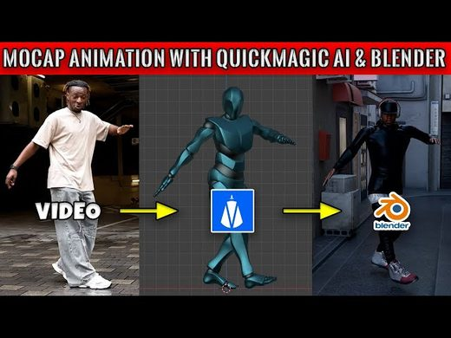
SECTION 08
THE ENEMY
↑ back to index
Across the island you need to be careful. Danger is usually close, and it tends to be silent.
ENVIRONMENTAL THREATS
  BEAR TRAPS  Laid down across the island. You can disarm them and set them up yourself; they can also trap enemies. | 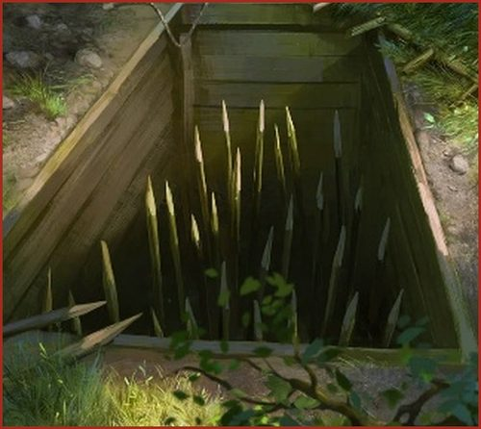  PUNJI TRAPS  Agonizing pain that is often mortal. Some of these pits are hidden. Their presence makes them a threat that forces you to reconsider how you explore the island.

MONSTERS
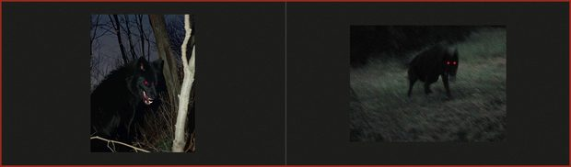  WOLVES  Nimble and fast. They usually come in packs. They are afraid of fire.  MOVEMENT They roam the island freely, usually in packs.  ATTACK They circle you a few times and start to pick at you with bites.  DEFENSE If you hit them, they will stop attacking you and return to the circling movement. If dealt enough damage they will flee and restart their roaming behavior. | 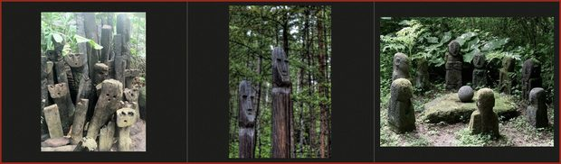  STONE TOTEMS  Entities of the forest. They won't move as long as you are watching them. If you don't get rid of them, they will slow you down.  MOVEMENT They don't move; they are placed near altars or bodies of water. If you engage with them, they will get closer to you when you are not looking.  ATTACK The closer you are to them, the more your speed and stamina stats drop.  DEFENSE No defense — a few hits break them.
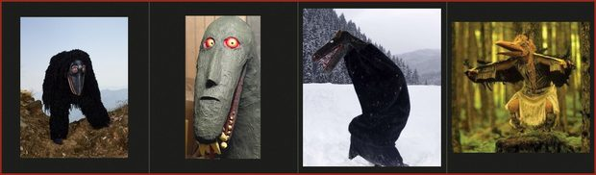  FURMAN  Gnarly creature that attacks like a berserker. Avoid contact, and eliminate as a priority if you can't avoid it.  MOVEMENT They can be found in plains or the forest, usually sleeping or roaming.  ATTACK If they spot you they will charge towards you and start dealing heavy bites. Their charge also induces fear factor.  DEFENSE They have no tactic but to charge like a berserker, and they have a lot of health. Heavy blows or attacks can stun them for some seconds. | 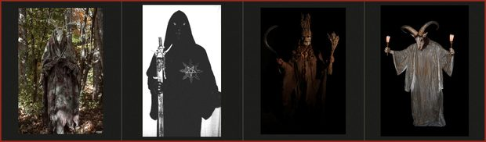  CULTIST — PRIEST  High-ranking member of the cult. Specializes in ranged attacks.  MOVEMENT They are always near an altar or a fireplace. They can also be summoned by the spotters.  ATTACK They use crossbows and blow darts with poison (which induce hallucinations). Outside of the MVP, in later stages, they can cast spells.  DEFENSE They attack from a distance. If the player starts attacking them and there are allied cultists nearby, they move in zigzag to a new position.
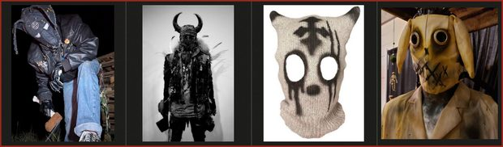  CULTIST — ZEALOT  Specializes in ambushes and melee attacks.  MOVEMENT They are very quiet and their black attire hides them well in the darkness; they can be anywhere. They usually start moving only after spotting you. If you haven't seen them, they will only move when your back is turned. Once spotted they will charge. If they lose you, they will try to follow you from a distance.  ATTACK They use melee weapons: knives and scythes. They can also throw Molotov cocktails. If they attack you from behind, they can be fatal.  DEFENSE They have low health; their best defense is being sneaky. | 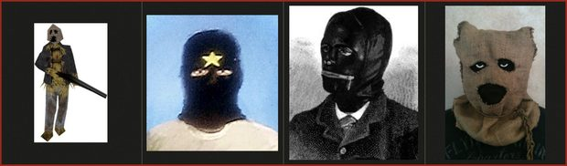  CULTIST — SPOTTER  Explorers of the cult. They can alert other cultists to your presence.  MOVEMENT They roam the map cautiously, with lamps. They can also be in groups at altars or in buildings.  ATTACK They use either a shotgun or clubs for melee attacks. They can alert and spawn more cultists with their whistle or a flare gun.  DEFENSE Average Joe.
SECTION 09
GENERAL ITEMS
↑ back to index
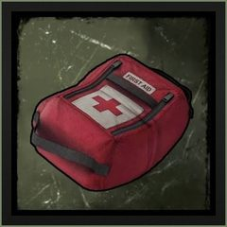  MEDKIT  CONSUMABLE  Single use, medium healing. | 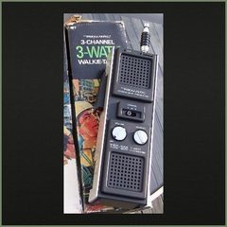  WALKIE TALKIE  EQUIPMENT  Useful to detect enemies, needed for communication. You can use the call function to hear the other radio from a distance or create a distraction. Consumes batteries. | 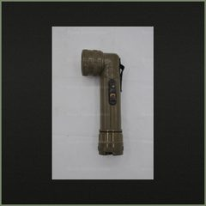  FLASHLIGHT  EQUIPMENT  Consumes batteries.
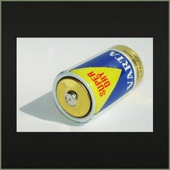  D BATTERIES  CONSUMABLE  Needed to power up some items. | 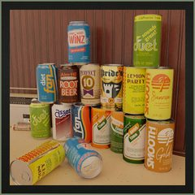  SODA CAN  CONSUMABLE  Gives a slight healing boost and a stamina boost. | 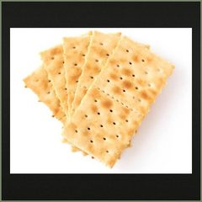  CRACKERS  CONSUMABLE  Gives a small healing boost and a slight stamina boost.
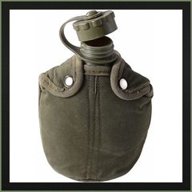  CANTEEN  CONSUMABLE (REFILLABLE)  Drinking water can help with some stats; it also helps with stamina recovery. Fill the canteen at springs or wells. | 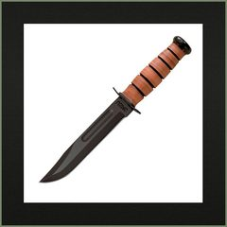  KA-BAR KNIFE  MELEE  Default melee weapon. Fast slashes; requires extreme close distance with the enemy. | 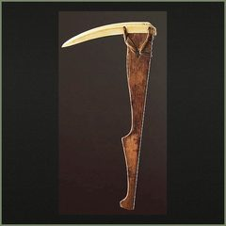  INUIT PICKAXE  MELEE  Heavy and slow blows. Medium-range melee attacks. Will break after a while.
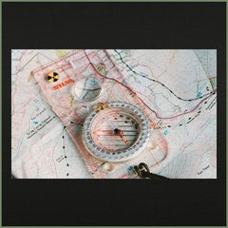  MAP AND COMPASS  EQUIPMENT  Used to navigate the island. Deploying and using the item will lock you in position and expose you. | 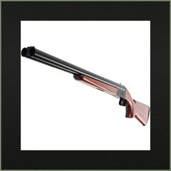  DOUBLE BARREL  FIREARM  Extreme damage at close range, very loud. | 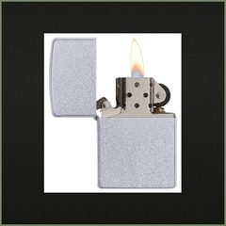  ZIPPO  EQUIPMENT  Requires gas. Convenient small source of light.
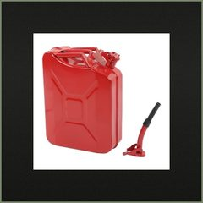  GAS CAN  EQUIPMENT  Required to start some objectives, and can refill the Zippo. It can be used for explosive traps. | 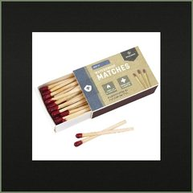  MATCHES  CONSUMABLE  Emergency light source. | 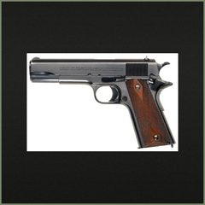  .45 PISTOL  FIREARM  Reliable, high stopping power.
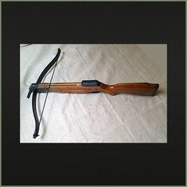  CROSSBOW  RANGED  Silent, deadly. | 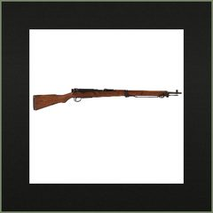  ARISAKA RIFLE  FIREARM  Long-range weapon, high damage. | 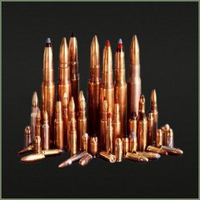  AMMO  CONSUMABLE  Can be found across the island in certain spots. Scarce.

